Biofuels production, 2000-2010

CSV dataset copy/pasted at end of document and linked below.

Jupyter file: <https://drive.google.com/open?id=1s4BTOS1rLVMR79wzk17kC5tk3obRoM3v>

CSV: <https://drive.google.com/open?id=1__aVonGFB3aQPNluMlZoxmgWLtA4N9n3>

This data set covers the total production of biofuels by country in thousands of gallons produced per day, averaged over the year. This is *not* a necessarily accurate statistic, as the definition of what a biofuel is varies by country and the means to record the scale of production weren’t necessarily present in all nations throughout the time period. However, given that proviso, there are interesting things to be plucked from the data.

**Part 1**

The first thing that stands out is that there’s a noticeable hump around the 2006-2008 mark, with the exact timing and degree of change differing between countries. Some nations peaked *hard*, and then keep their capital accumulation relatively steady (Canada, bottom right), while others’ production rose gradually but then dropped dramatically in 2009 (India). Most producers of biofuel went for an in-between strategy, considerably ramping up production until 2006-07, but then slowing down the increase after 2007.

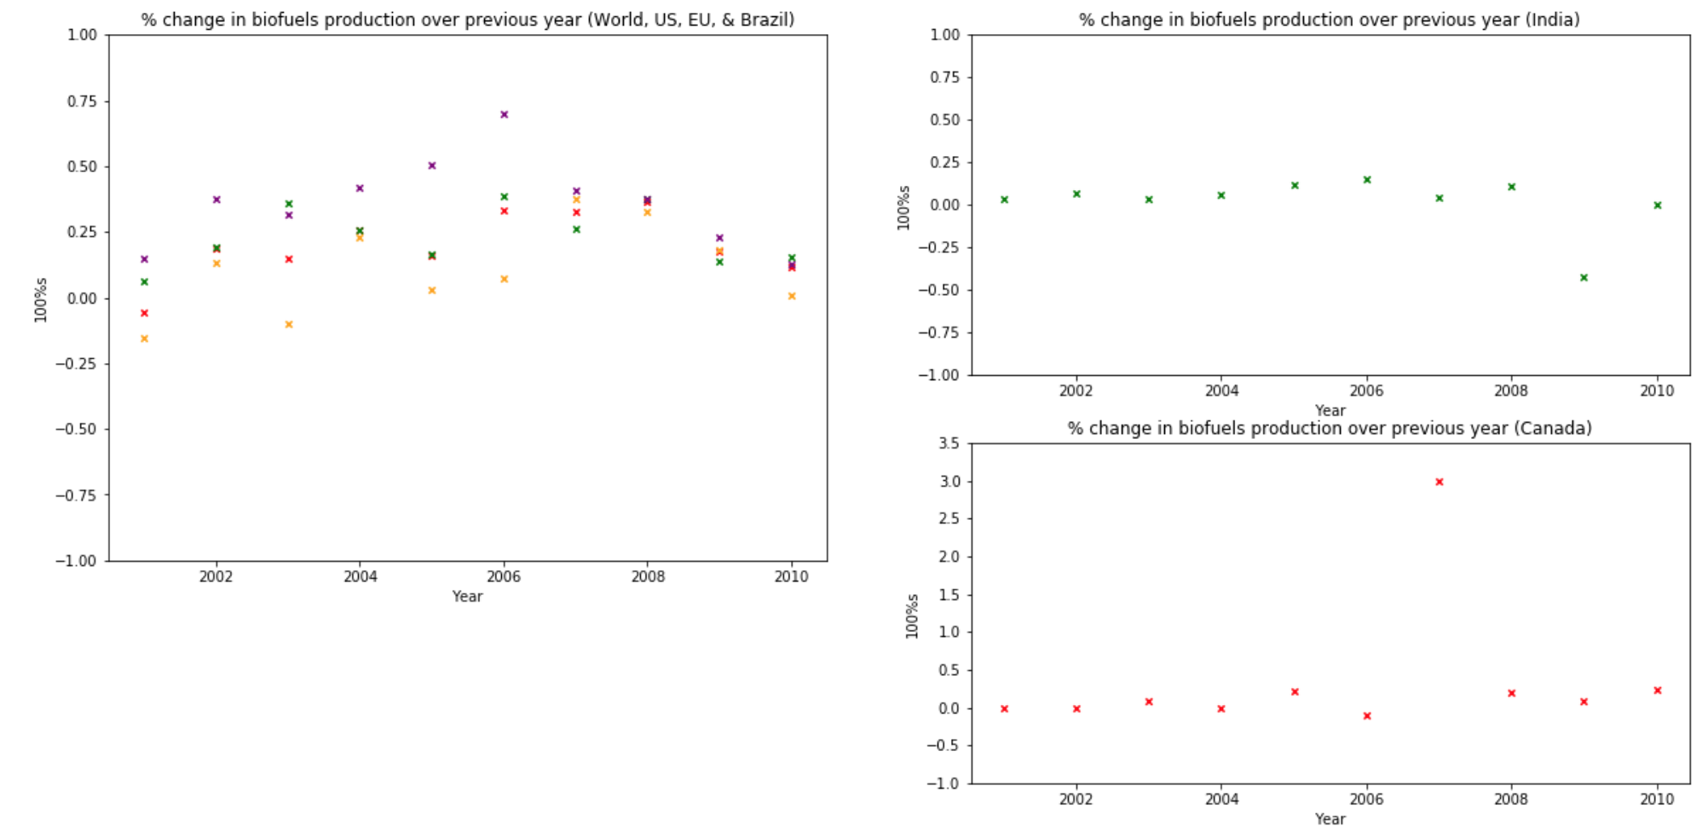

The reason for this was likely the worldwide price of oil, which gradually rose in the early 2000s, spiked in 2007 and early 2008, and then crashed in late 2008. Other factors, such as the effects of national agriculture policies, weather patterns, and capital flows, likely had strong impacts on individual nations as well, but the global production (red ‘x’s on the left-hand graph) shows at least a small correlation with global oil prices. (<https://www.macrotrends.net/1369/crude-oil-price-history-chart>)

One last thing to note with these graphs is that they’re percentage change from the previous year - if the mark is lower than the previous one but is still above zero, *production still increased* *that year*, it just didn’t go up as fast as in the previous year. For most nations (I’ll get to the exceptions below) the drop in oil prices just meant that they scaled back on their plans to *increase* production, not that they should actually produce less.

**Part 2**

Only a few nations actually had lower production in 2010 than they did in 2007. Those unlucky(?) few are illustrated below. (Note that these are total production, not % change in production like the previous graphs.)

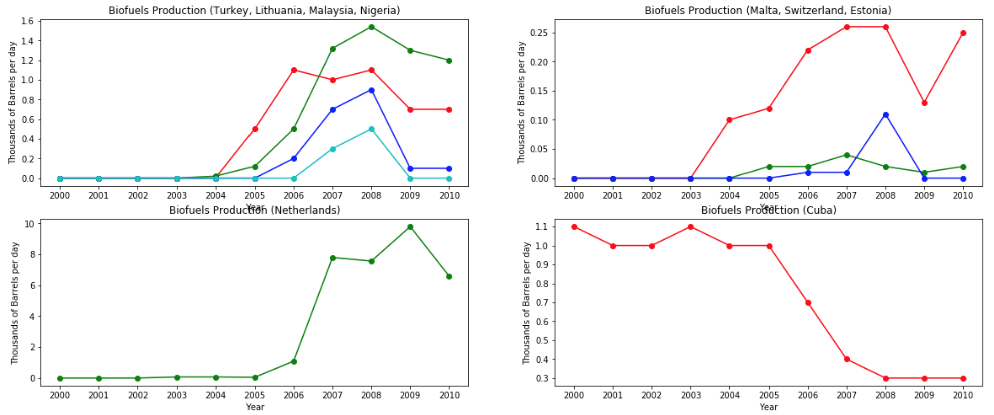

As you can see, most of these nations had zero biofuels production in 2000, and gradually ramped up production from those humble beginnings before the drop in oil prices in 2008. The two major outliers to this pattern were the Netherlands and Cuba, for completely different reasons. The Netherlands made monumental gains that proved slightly fragile under the influence of oil price shocks - going from 50 gallons a day in 2005 to 1,090 gallons a day in 2006, peaking at 9.8 thousand gallons in 2009 before dropping to “only” 6.6 thousand gallons in 2010. Cuba, on the other hand, began the decade producing 1.1 thousand and never went higher, dropping to .3 gallons by 2008. This was happening at the same time as a dramatic rise in the price of oil, too, which likely means that Cuban agricultural or trade policies were to blame.

**Part 3**

The final set of graphs are a comparison of American and global production. Note that the y-scale of both graphs does not start at zero - I was unable to get the y-scale instructions to work, for some reason, and decided to move on after ten minutes of unproductive research and trying to fix it.

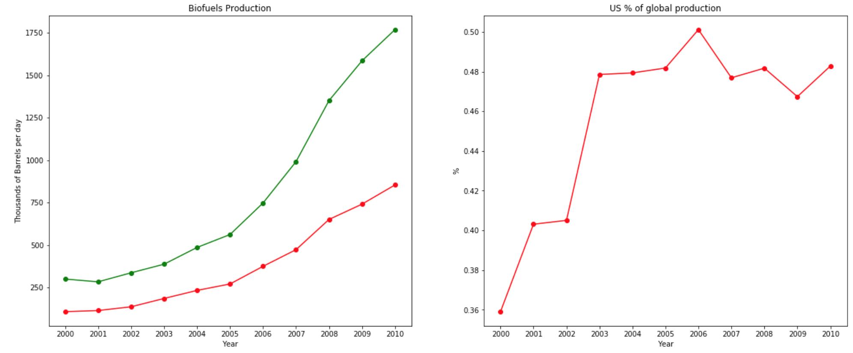

As you can see, US production starts very high and grows rapidly, but then gets outpaced by the cumulative growth of other producers across the globe over the course of the decade. US production rises from 36% of global production in 2000, peaks at almost 50% in 2006, and then wobbles around the 47% mark for the rest of the decade.

Country,2000,2001,2002,2003,2004,2005,2006,2007,2008,2009,2010

North America,112.06,118.72,140.78,190.13,237.73,276.67,379.95,494.23,676.28,768.50,888.30

Bermuda,0.00,0.00,0.00,0.00,0.00,0.00,0.00,0.00,0.00,0.00,0.00

Canada,4.50,4.50,4.50,4.90,4.90,6.00,5.40,21.60,25.70,27.81,34.20

Greenland,0.00,0.00,0.00,0.00,0.00,0.00,0.00,0.00,0.00,0.00,0.00

Mexico,0.00,0.00,0.00,0.00,0.00,0.00,0.00,0.10,0.10,0.10,0.40

Saint Pierre and Miquelon,0.00,0.00,0.00,0.00,0.00,0.00,0.00,0.00,0.00,0.00,0.00

United States,107.56,114.22,136.28,185.23,232.83,270.67,374.55,472.53,650.48,740.58,853.70

Central & South America,168.09,142.60,161.39,145.34,178.32,184.39,201.68,275.61,364.37,438.08,455.47

Antarctica,0.00,0.00,0.00,0.00,0.00,0.00,0.00,0.00,0.00,0.00,0.00

Antigua and Barbuda,0.00,0.00,0.00,0.00,0.00,0.00,0.00,0.00,0.00,0.00,0.00

Argentina,0.10,0.20,0.20,0.20,0.20,0.30,0.30,0.30,0.30,0.55,11.90

Aruba,0.00,0.00,0.00,0.00,0.00,0.00,0.00,0.00,0.00,0.00,0.00

"Bahamas, The",0.00,0.00,0.00,0.00,0.00,0.00,0.00,0.00,0.00,0.00,0.00

Barbados,0.00,0.00,0.00,0.00,0.00,0.00,0.00,0.00,0.00,0.00,0.00

Belize,0.00,0.00,0.00,0.00,0.00,0.00,0.00,0.00,0.00,0.00,0.00

Bolivia,0.00,0.00,0.00,0.00,0.00,0.00,0.00,0.00,0.00,0.00,0.00

Brazil,166.85,141.38,160.17,144.02,177.12,181.96,195.23,268.48,355.65,420.27,424.34

Cayman Islands,0.00,0.00,0.00,0.00,0.00,0.00,0.00,0.00,0.00,0.00,0.00

Chile,0.00,0.00,0.00,0.00,0.00,0.00,0.00,0.00,0.00,0.00,0.00

Colombia,0.00,0.00,0.00,0.00,0.00,0.50,4.60,4.80,5.80,11.30,12.00

Costa Rica,0.00,0.00,0.00,0.00,0.00,0.00,0.00,0.05,0.05,0.50,0.50

Cuba,1.10,1.00,1.00,1.10,1.00,1.00,0.70,0.40,0.30,0.30,0.30

Dominica,0.00,0.00,0.00,0.00,0.00,0.00,0.00,0.00,0.00,0.00,0.00

Dominican Republic,0.00,0.00,0.00,0.00,0.00,0.00,0.00,0.00,0.00,0.00,0.00

Ecuador,0.00,0.00,0.00,0.00,0.00,0.00,0.00,0.00,0.00,0.00,0.20

El Salvador,0.00,0.00,0.00,0.00,0.00,0.00,0.00,0.00,0.00,0.00,0.00

Falkland Islands (Islas Malvinas),0.00,0.00,0.00,0.00,0.00,0.00,0.00,0.00,0.00,0.00,0.00

French Guiana,0.00,0.00,0.00,0.00,0.00,0.00,0.00,0.00,0.00,0.00,0.00

Grenada,0.00,0.00,0.00,0.00,0.00,0.00,0.00,0.00,0.00,0.00,0.00

Guadeloupe,0.00,0.00,0.00,0.00,0.00,0.00,0.00,0.00,0.00,0.00,0.00

Guatemala,0.00,0.00,0.00,0.00,0.00,0.00,0.00,0.00,0.00,0.01,0.01

Guyana,0.00,0.00,0.00,0.00,0.00,0.00,0.00,0.00,0.00,0.00,0.00

Haiti,0.00,0.00,0.00,0.00,0.00,0.00,0.00,0.00,0.00,0.00,0.00

Honduras,0.00,0.00,0.00,0.00,0.00,0.00,0.01,0.02,0.02,0.01,0.02

Jamaica,0.00,0.00,0.00,0.00,0.00,0.00,0.00,0.00,0.10,1.00,1.00

Martinique,0.00,0.00,0.00,0.00,0.00,0.00,0.00,0.00,0.00,0.00,0.00

Montserrat,0.00,0.00,0.00,0.00,0.00,0.00,0.00,0.00,0.00,0.00,0.00

Netherlands Antilles,0.00,0.00,0.00,0.00,0.00,0.00,0.00,0.00,0.00,0.00,0.00

Nicaragua,0.00,0.00,0.00,0.00,0.00,0.00,0.00,0.00,0.00,0.00,0.00

Panama,0.00,0.00,0.00,0.00,0.00,0.00,0.00,0.00,0.00,0.00,0.00

Paraguay,0.04,0.02,0.02,0.02,0.00,0.60,0.80,1.10,1.60,2.00,2.40

Peru,0.00,0.00,0.00,0.00,0.00,0.00,0.00,0.40,0.50,2.00,2.50

Puerto Rico,0.00,0.00,0.00,0.00,0.00,0.00,0.00,0.00,0.00,0.00,0.00

Saint Kitts and Nevis,0.00,0.00,0.00,0.00,0.00,0.00,0.00,0.00,0.00,0.00,0.00

Saint Lucia,0.00,0.00,0.00,0.00,0.00,0.00,0.00,0.00,0.00,0.00,0.00

Saint Vincent/Grenadines,0.00,0.00,0.00,0.00,0.00,0.00,0.00,0.00,0.00,0.00,0.00

Suriname,0.00,0.00,0.00,0.00,0.00,0.00,0.00,0.00,0.00,0.00,0.00

Trinidad and Tobago,0.00,0.00,0.00,0.00,0.00,0.00,0.00,0.00,0.00,0.00,0.00

Turks and Caicos Islands,0.00,0.00,0.00,0.00,0.00,0.00,0.00,0.00,0.00,0.00,0.00

Uruguay,0.00,0.00,0.00,0.00,0.00,0.03,0.04,0.06,0.05,0.14,0.30

Venezuela,0.00,0.00,0.00,0.00,0.00,0.00,0.00,0.00,0.00,0.00,0.00

"Virgin Islands, U.S.",0.00,0.00,0.00,0.00,0.00,0.00,0.00,0.00,0.00,0.00,0.00

"Virgin Islands, British",0.00,0.00,0.00,0.00,0.00,0.00,0.00,0.00,0.00,0.00,0.00

Europe,16.30,18.72,25.76,33.96,48.17,72.51,123.02,173.39,238.18,292.55,329.64

Albania,0.00,0.00,0.00,0.00,0.00,0.00,0.00,0.00,0.00,0.00,0.00

Austria,0.40,0.40,0.50,0.60,1.10,1.70,6.40,7.70,9.70,12.40,12.50

Belgium,0.00,0.00,0.00,0.00,0.00,0.00,0.02,2.00,2.30,7.40,8.20

Bosnia and Herzegovina,0.00,0.00,0.00,0.00,0.00,0.00,0.00,0.00,0.00,0.00,0.00

Bulgaria,0.00,0.00,0.00,0.00,0.00,0.00,0.10,0.04,0.08,0.10,0.80

Croatia,0.00,0.00,0.00,0.00,0.00,0.00,0.00,0.06,0.04,0.06,0.10

Cyprus,0.00,0.00,0.00,0.00,0.00,0.00,0.00,0.02,0.31,0.33,0.33

Czech Republic,1.40,1.00,1.40,1.40,0.70,0.10,0.44,0.70,2.80,4.90,5.80

Denmark,0.00,0.00,0.00,0.00,0.00,0.00,0.10,0.20,0.21,0.30,1.10

Faroe Islands,0.00,0.00,0.00,0.00,0.00,0.00,0.00,0.00,0.00,0.00,0.00

Finland,0.00,0.00,0.02,0.10,0.10,0.00,0.02,0.10,2.40,3.90,4.50

France,8.00,7.86,8.32,7.57,8.18,9.52,18.40,34.30,54.60,59.00,55.00

Germany,4.90,6.80,10.80,15.70,21.90,40.70,67.00,74.00,66.00,68.00,75.50

Gibraltar,0.00,0.00,0.00,0.00,0.00,0.00,0.00,0.00,0.00,0.00,0.00

Greece,0.00,0.00,0.00,0.00,0.00,0.06,1.00,1.90,1.50,1.70,2.80

Hungary,0.00,0.00,0.00,0.00,0.00,0.10,0.41,0.94,4.20,4.30,4.10

Iceland,0.00,0.00,0.00,0.00,0.00,0.00,0.00,0.00,0.01,0.01,0.01

Ireland,0.00,0.00,0.00,0.00,0.00,0.02,0.06,0.60,1.40,2.00,2.00

Italy,0.00,0.00,0.00,0.00,5.60,4.10,4.60,4.20,16.00,27.30,34.70

Luxembourg,0.00,0.00,0.00,0.00,0.00,0.01,0.01,0.73,0.83,0.92,0.92

Macedonia,0.00,0.00,0.00,0.00,0.00,0.00,0.00,0.00,0.01,0.01,0.01

Malta,0.00,0.00,0.00,0.00,0.00,0.02,0.02,0.04,0.02,0.01,0.02

Netherlands,0.00,0.00,0.00,0.07,0.07,0.05,1.09,7.80,7.57,9.80,6.60

Norway,0.00,0.00,0.00,0.00,0.10,0.10,0.10,0.68,1.88,2.20,2.70

Poland,0.00,0.00,0.00,1.00,0.50,1.30,2.60,2.50,11.00,13.00,18.00

Portugal,0.00,0.00,0.00,0.00,0.00,0.00,1.60,3.00,2.80,5.00,7.00

Romania,0.00,0.00,0.00,0.00,0.00,0.00,0.50,0.90,2.60,4.70,5.50

Slovakia,0.00,0.60,0.10,0.04,0.02,0.20,0.94,2.00,3.10,3.70,4.00

Slovenia,0.00,0.00,0.00,0.00,0.00,0.11,0.10,0.31,0.57,0.68,1.00

Spain,1.60,1.60,3.50,5.00,5.20,7.20,5.20,9.90,15.00,25.00,34.00

Sweden,0.00,0.46,1.06,2.18,4.20,4.50,6.50,8.40,10.10,10.00,11.00

Switzerland,0.00,0.00,0.00,0.00,0.10,0.12,0.22,0.26,0.26,0.13,0.25

Turkey,0.00,0.00,0.00,0.00,0.00,0.50,1.10,1.00,1.10,0.70,0.70

United Kingdom,0.00,0.00,0.06,0.30,0.40,2.10,4.50,8.60,18.80,23.50,29.00

Eurasia,0.00,0.00,0.00,0.00,0.02,0.24,0.59,1.39,1.89,1.98,2.60

Armenia,0.00,0.00,0.00,0.00,0.00,0.00,0.00,0.00,0.00,0.00,0.00

Azerbaijan,0.00,0.00,0.00,0.00,0.00,0.00,0.00,0.00,0.00,0.00,0.00

Belarus,0.00,0.00,0.00,0.00,0.00,0.00,0.00,0.00,0.20,0.50,0.70

Estonia,0.00,0.00,0.00,0.00,0.00,0.00,0.01,0.01,0.11,0.00,0.00

Georgia,0.00,0.00,0.00,0.00,0.00,0.00,0.00,0.00,0.00,0.00,0.00

Kazakhstan,0.00,0.00,0.00,0.00,0.00,0.00,0.00,0.00,0.00,0.00,0.00

Kyrgyzstan,0.00,0.00,0.00,0.00,0.00,0.00,0.00,0.00,0.00,0.00,0.00

Latvia,0.00,0.00,0.00,0.00,0.00,0.12,0.08,0.06,0.04,0.18,0.70

Lithuania,0.00,0.00,0.00,0.00,0.02,0.12,0.50,1.32,1.54,1.30,1.20

Moldova,0.00,0.00,0.00,0.00,0.00,0.00,0.00,0.00,0.00,0.00,0.00

Russia,0.00,0.00,0.00,0.00,0.00,0.00,0.00,0.00,0.00,0.00,0.00

Tajikistan,0.00,0.00,0.00,0.00,0.00,0.00,0.00,0.00,0.00,0.00,0.00

Turkmenistan,0.00,0.00,0.00,0.00,0.00,0.00,0.00,0.00,0.00,0.00,0.00

Ukraine,0.00,0.00,0.00,0.00,0.00,0.00,0.00,0.00,0.00,0.00,0.00

Uzbekistan,0.00,0.00,0.00,0.00,0.00,0.00,0.00,0.00,0.00,0.00,0.00

Middle East,0.00,0.00,0.00,0.00,0.00,0.00,0.00,0.10,0.10,0.10,0.10

Bahrain,0.00,0.00,0.00,0.00,0.00,0.00,0.00,0.00,0.00,0.00,0.00

Iran,0.00,0.00,0.00,0.00,0.00,0.00,0.00,0.00,0.00,0.00,0.00

Iraq,0.00,0.00,0.00,0.00,0.00,0.00,0.00,0.00,0.00,0.00,0.00

Israel,0.00,0.00,0.00,0.00,0.00,0.00,0.00,0.10,0.10,0.10,0.10

Jordan,0.00,0.00,0.00,0.00,0.00,0.00,0.00,0.00,0.00,0.00,0.00

Kuwait,0.00,0.00,0.00,0.00,0.00,0.00,0.00,0.00,0.00,0.00,0.00

Lebanon,0.00,0.00,0.00,0.00,0.00,0.00,0.00,0.00,0.00,0.00,0.00

Oman,0.00,0.00,0.00,0.00,0.00,0.00,0.00,0.00,0.00,0.00,0.00

Palestine,0.00,0.00,0.00,0.00,0.00,0.00,0.00,0.00,0.00,0.00,0.00

Qatar,0.00,0.00,0.00,0.00,0.00,0.00,0.00,0.00,0.00,0.00,0.00

Saudi Arabia,0.00,0.00,0.00,0.00,0.00,0.00,0.00,0.00,0.00,0.00,0.00

Syria,0.00,0.00,0.00,0.00,0.00,0.00,0.00,0.00,0.00,0.00,0.00

United Arab Emirates,0.00,0.00,0.00,0.00,0.00,0.00,0.00,0.00,0.00,0.00,0.00

Yemen,0.00,0.00,0.00,0.00,0.00,0.00,0.00,0.00,0.00,0.00,0.00

Africa,0.20,0.20,0.20,0.20,0.20,0.10,0.10,0.40,0.64,0.15,0.20

Algeria,0.00,0.00,0.00,0.00,0.00,0.00,0.00,0.00,0.00,0.00,0.00

Angola,0.00,0.00,0.00,0.00,0.00,0.00,0.00,0.00,0.00,0.00,0.00

Benin,0.00,0.00,0.00,0.00,0.00,0.00,0.00,0.00,0.00,0.00,0.00

Botswana,0.00,0.00,0.00,0.00,0.00,0.00,0.00,0.00,0.00,0.00,0.00

Burkina Faso,0.00,0.00,0.00,0.00,0.00,0.00,0.00,0.00,0.00,0.00,0.00

Burundi,0.00,0.00,0.00,0.00,0.00,0.00,0.00,0.00,0.00,0.00,0.00

Cameroon,0.00,0.00,0.00,0.00,0.00,0.00,0.00,0.00,0.00,0.00,0.00

Cape Verde,0.00,0.00,0.00,0.00,0.00,0.00,0.00,0.00,0.00,0.00,0.00

Central African Republic,0.00,0.00,0.00,0.00,0.00,0.00,0.00,0.00,0.00,0.00,0.00

Chad,0.00,0.00,0.00,0.00,0.00,0.00,0.00,0.00,0.00,0.00,0.00

Comoros,0.00,0.00,0.00,0.00,0.00,0.00,0.00,0.00,0.00,0.00,0.00

Congo (Brazzaville),0.00,0.00,0.00,0.00,0.00,0.00,0.00,0.00,0.00,0.00,0.00

Congo (Kinshasa),0.00,0.00,0.00,0.00,0.00,0.00,0.00,0.00,0.00,0.00,0.00

Cote dIvoire (IvoryCoast),0.00,0.00,0.00,0.00,0.00,0.00,0.00,0.00,0.00,0.00,0.00

Djibouti,0.00,0.00,0.00,0.00,0.00,0.00,0.00,0.00,0.00,0.00,0.00

Egypt,0.00,0.00,0.00,0.00,0.00,0.00,0.00,0.00,0.00,0.00,0.00

Equatorial Guinea,0.00,0.00,0.00,0.00,0.00,0.00,0.00,0.00,0.00,0.00,0.00

Eritrea,0.00,0.00,0.00,0.00,0.00,0.00,0.00,0.00,0.00,0.00,0.00

Ethiopia,0.00,0.00,0.00,0.00,0.00,0.00,0.00,0.00,0.03,0.03,0.05

Gabon,0.00,0.00,0.00,0.00,0.00,0.00,0.00,0.00,0.00,0.00,0.00

"Gambia, The",0.00,0.00,0.00,0.00,0.00,0.00,0.00,0.00,0.00,0.00,0.00

Ghana,0.00,0.00,0.00,0.00,0.00,0.00,0.00,0.00,0.00,0.00,0.00

Guinea,0.00,0.00,0.00,0.00,0.00,0.00,0.00,0.00,0.00,0.00,0.00

Guinea-Bissau,0.00,0.00,0.00,0.00,0.00,0.00,0.00,0.00,0.00,0.00,0.00

Kenya,0.00,0.00,0.00,0.00,0.00,0.00,0.00,0.00,0.00,0.00,0.00

Lesotho,0.00,0.00,0.00,0.00,0.00,0.00,0.00,0.00,0.00,0.00,0.00

Liberia,0.00,0.00,0.00,0.00,0.00,0.00,0.00,0.00,0.00,0.00,0.00

Libya,0.00,0.00,0.00,0.00,0.00,0.00,0.00,0.00,0.00,0.00,0.00

Madagascar,0.00,0.00,0.00,0.00,0.00,0.00,0.00,0.00,0.00,0.00,0.00

Malawi,0.20,0.20,0.20,0.20,0.20,0.10,0.10,0.10,0.10,0.10,0.10

Mali,0.00,0.00,0.00,0.00,0.00,0.00,0.00,0.00,0.00,0.00,0.00

Mauritania,0.00,0.00,0.00,0.00,0.00,0.00,0.00,0.00,0.00,0.00,0.00

Mauritius,0.00,0.00,0.00,0.00,0.00,0.00,0.00,0.00,0.00,0.00,0.00

Morocco,0.00,0.00,0.00,0.00,0.00,0.00,0.00,0.00,0.00,0.00,0.00

Mozambique,0.00,0.00,0.00,0.00,0.00,0.00,0.00,0.00,0.00,0.00,0.00

Namibia,0.00,0.00,0.00,0.00,0.00,0.00,0.00,0.00,0.00,0.00,0.00

Niger,0.00,0.00,0.00,0.00,0.00,0.00,0.00,0.00,0.00,0.00,0.00

Nigeria,0.00,0.00,0.00,0.00,0.00,0.00,0.00,0.30,0.50,0.00,0.00

Reunion,0.00,0.00,0.00,0.00,0.00,0.00,0.00,0.00,0.00,0.00,0.00

Rwanda,0.00,0.00,0.00,0.00,0.00,0.00,0.00,0.00,0.00,0.00,0.01

Saint Helena,0.00,0.00,0.00,0.00,0.00,0.00,0.00,0.00,0.00,0.00,0.00

Sao Tome and Principe,0.00,0.00,0.00,0.00,0.00,0.00,0.00,0.00,0.00,0.00,0.00

Senegal,0.00,0.00,0.00,0.00,0.00,0.00,0.00,0.00,0.00,0.00,0.00

Seychelles,0.00,0.00,0.00,0.00,0.00,0.00,0.00,0.00,0.00,0.00,0.00

Sierra Leone,0.00,0.00,0.00,0.00,0.00,0.00,0.00,0.00,0.00,0.00,0.00

Somalia,0.00,0.00,0.00,0.00,0.00,0.00,0.00,0.00,0.00,0.00,0.00

South Africa,0.00,0.00,0.00,0.00,0.00,0.00,0.00,0.00,0.01,0.01,0.03

Sudan,0.00,0.00,0.00,0.00,0.00,0.00,0.00,0.00,0.00,0.00,0.00

Swaziland,0.00,0.00,0.00,0.00,0.00,0.00,0.00,0.00,0.00,0.00,0.00

Tanzania,0.00,0.00,0.00,0.00,0.00,0.00,0.00,0.00,0.00,0.01,0.01

Togo,0.00,0.00,0.00,0.00,0.00,0.00,0.00,0.00,0.00,0.00,0.00

Tunisia,0.00,0.00,0.00,0.00,0.00,0.00,0.00,0.00,0.00,0.00,0.00

Uganda,0.00,0.00,0.00,0.00,0.00,0.00,0.00,0.00,0.00,0.00,0.00

Western Sahara,0.00,0.00,0.00,0.00,0.00,0.00,0.00,0.00,0.00,0.00,0.00

Zambia,0.00,0.00,0.00,0.00,0.00,0.00,0.00,0.00,0.00,0.00,0.00

Zimbabwe,0.00,0.00,0.00,0.00,0.00,0.00,0.00,0.00,0.00,0.00,0.00

Asia & Oceania,2.90,3.10,8.32,17.44,21.30,27.88,42.06,45.79,68.85,83.15,91.97

Afghanistan,0.00,0.00,0.00,0.00,0.00,0.00,0.00,0.00,0.00,0.00,0.00

American Samoa,0.00,0.00,0.00,0.00,0.00,0.00,0.00,0.00,0.00,0.00,0.00

Australia,0.00,0.00,0.00,0.00,0.10,0.70,1.60,2.20,3.50,5.40,8.00

Bangladesh,0.00,0.00,0.00,0.00,0.00,0.00,0.00,0.00,0.00,0.00,0.00

Bhutan,0.00,0.00,0.00,0.00,0.00,0.00,0.00,0.00,0.00,0.00,0.00

Brunei,0.00,0.00,0.00,0.00,0.00,0.00,0.00,0.00,0.00,0.00,0.00

Burma (Myanmar),0.00,0.00,0.00,0.00,0.00,0.00,0.00,0.00,0.00,0.00,0.00

Cambodia,0.00,0.00,0.00,0.00,0.00,0.00,0.00,0.00,0.00,0.00,0.00

China,0.00,0.10,5.10,13.90,17.30,21.50,32.00,30.70,39.40,43.00,43.00

Cook Islands,0.00,0.00,0.00,0.00,0.00,0.00,0.00,0.00,0.00,0.00,0.00

Fiji,0.00,0.00,0.00,0.00,0.00,0.00,0.00,0.00,0.00,0.00,0.01

French Polynesia,0.00,0.00,0.00,0.00,0.00,0.00,0.00,0.00,0.00,0.00,0.00

Guam,0.00,0.00,0.00,0.00,0.00,0.00,0.00,0.00,0.00,0.00,0.00

Hong Kong,0.00,0.00,0.00,0.00,0.00,0.00,0.00,0.00,0.00,0.00,0.10

India,2.90,3.00,3.20,3.30,3.50,3.90,4.50,4.70,5.20,3.00,3.00

Indonesia,0.00,0.00,0.00,0.00,0.00,0.04,0.30,0.60,1.20,2.20,4.00

Japan,0.00,0.00,0.00,0.20,0.20,0.20,0.20,0.30,0.30,0.70,1.30

Kiribati,0.00,0.00,0.00,0.00,0.00,0.00,0.00,0.00,0.00,0.00,0.00

"Korea, North",0.00,0.00,0.00,0.00,0.00,0.00,0.00,0.00,0.00,0.00,0.00

"Korea, South",0.00,0.00,0.02,0.04,0.10,0.20,0.90,1.70,3.20,5.00,6.50

Laos,0.00,0.00,0.00,0.00,0.00,0.00,0.00,0.00,0.00,0.00,0.00

Macau,0.00,0.00,0.00,0.00,0.00,0.00,0.00,0.00,0.00,0.00,0.00

Malaysia,0.00,0.00,0.00,0.00,0.00,0.00,0.20,0.70,0.90,0.10,0.10

Maldives,0.00,0.00,0.00,0.00,0.00,0.00,0.00,0.00,0.00,0.00,0.00

Mongolia,0.00,0.00,0.00,0.00,0.00,0.00,0.00,0.00,0.00,0.00,0.00

Nauru,0.00,0.00,0.00,0.00,0.00,0.00,0.00,0.00,0.00,0.00,0.00

Nepal,0.00,0.00,0.00,0.00,0.00,0.00,0.00,0.00,0.00,0.00,0.00

New Caledonia,0.00,0.00,0.00,0.00,0.00,0.00,0.00,0.00,0.00,0.00,0.00

New Zealand,0.00,0.00,0.00,0.00,0.00,0.00,0.00,0.02,0.12,0.12,0.12

Niue,0.00,0.00,0.00,0.00,0.00,0.00,0.00,0.00,0.00,0.00,0.00

Pakistan,0.00,0.00,0.00,0.00,0.00,0.00,0.00,0.00,0.00,0.00,0.20

Papua New Guinea,0.00,0.00,0.00,0.00,0.00,0.00,0.00,0.00,0.00,0.00,0.00

Philippines,0.00,0.00,0.00,0.00,0.00,0.04,0.06,0.67,1.20,4.00,5.40

Samoa,0.00,0.00,0.00,0.00,0.00,0.00,0.00,0.00,0.00,0.00,0.00

Singapore,0.00,0.00,0.00,0.00,0.00,0.00,0.00,0.00,0.00,0.03,0.04

Solomon Islands,0.00,0.00,0.00,0.00,0.00,0.00,0.00,0.00,0.00,0.00,0.00

Sri Lanka,0.00,0.00,0.00,0.00,0.00,0.00,0.00,0.00,0.00,0.00,0.00

Taiwan,0.00,0.00,0.00,0.00,0.00,0.00,0.00,0.10,0.63,1.10,2.10

Thailand,0.00,0.00,0.00,0.00,0.10,1.30,2.30,4.10,13.20,18.50,18.00

Tonga,0.00,0.00,0.00,0.00,0.00,0.00,0.00,0.00,0.00,0.00,0.00

U.S. Pacific Islands,0.00,0.00,0.00,0.00,0.00,0.00,0.00,0.00,0.00,0.00,0.00

Vanuatu,0.00,0.00,0.00,0.00,0.00,0.00,0.00,0.00,0.00,0.00,0.00

Vietnam,0.00,0.00,0.00,0.00,0.00,0.00,0.00,0.00,0.00,0.00,0.10

Wake Island,0.00,0.00,0.00,0.00,0.00,0.00,0.00,0.00,0.00,0.00,0.00

World,299.55,283.33,336.45,387.07,485.74,561.79,747.40,990.90,1350.31,1584.50,1768.28